



Marketing Campaign Performance Dashboard
Submitted in partial fulfillment of completion of the course
AI MicroDegree
Year 2026
Submitted by:
Arsheta :- Developed the dashboard and assisted in designing and structuring the visuals.
Kashish Gautam:- :- Developed the dashboard using Microsoft Power BI and prepared the complete project documentation.
Tripti :- Created the project presentation (PPT) and contributed to video editing.
Kavita:- Assisted in presentation preparation, documentation support, and contributed to video editing.
Anuradha:- Supported in documentation and assisted in preparing the presentation content.
Under Guidance of:
Deepika singh (Edunet)
Abstract
The Marketing Campaign Performance Dashboard is developed using Microsoft Power BI to analyze the effectiveness of different marketing campaigns. It tracks key metrics such as clicks, impressions, ROI, and customer engagement across various channels like Social Media, Email, and Influencer Marketing. The dashboard provides interactive visualizations and insights, helping businesses make data-driven decisions and improve overall campaign performance.
This project helps businesses understand which marketing strategies are most effective and enables data-driven decision-making. With features like dynamic filters and real-time insights, the dashboard enhances usability and supports efficient performance tracking. Overall, the system provides a powerful tool for optimizing marketing efforts and improving return on investment.

Acknowledgement
We would like to express our sincere gratitude to everyone who helped us in completing the Marketing Campaign Performance Dashboard project successfully. First of all, we would like to thank our teachers and mentors for their continuous guidance, encouragement, and valuable suggestions throughout the project development process.
We are also thankful to our college and department for providing the necessary resources and a supportive learning environment that helped us complete this project effectively. The availability of tools like Microsoft Power BI played a crucial role in the successful completion of this project.
Finally, we would like to thank all those who directly or indirectly contributed to this project and supported us throughout its completion.
Team Composition and Workload Division
Arsheta :- Devloped the dashboard and assisted in designing and structuring the visuals.
Kashish Gautam:- Developed the dashboard using Microsoft Power BI and prepared the complete project documentation.
Tripti :- Created the project presentation (PPT) and contributed to video editing.
Kavita:- Assisted in presentation preparation, documentation support, and contributed to video editing.
Anuradha:- Supported in documentation and assisted in preparing the presentation content.
Table of Contents

Abstract.................................................................................... i
Acknowledgement .................................................................... ii
- Introduction to the Problem ............................................. 1
- Literature Review ................................................................. 2
- Proposed Solution ............................................................... 3
- Project Requirements ........................................................ 4
4.1 Technology Stack ......................................................... 4
4.2 Hardware Requirements ............................................. 5
4.3 Software Requirements .............................................. 6
4.4 Deployment Environment ......................................... 7
- User Requirements ............................................................... 8
- Design Documentation ......................................................... 9
- Implementation Details ........................................................ 10
- Testing and Validation ......................................................... 11
- Deployment ......................................................................... 12
- Future Scope ..................................................................... 13
- Conclusion ........................................................................... 1
Appendix A – Project Code ...................................................... 15
Appendix B – Project Screenshots .......................................... 16
Appendix C – Abbreviations ..................................................... 17
References ................................................................................. 18

- Introduction to Problem
Marketing data is often distributed across multiple platforms, making it difficult to track key performance indicators such as clicks, impressions, customer engagement, and return on investment (ROI). This fragmentation leads to limited visibility, inefficient decision-making, and suboptimal allocation of marketing resources.

Therefore, there is a critical need for a centralized and interactive analytical solution that can consolidate data, provide meaningful insights, and support data-driven decision-making. This project addresses this challenge by developing a Marketing Campaign Performance Dashboard using Microsoft Power BI, enabling efficient analysis and improved marketing performance.

- Literature Review
Various studies and industry reports highlight the importance of data analytics in improving marketing performance. Researchers have emphasized that using data visualization tools helps organizations better understand campaign effectiveness and customer behavior.
Previous work shows that tools like dashboards enable tracking of key metrics such as ROI, clicks, and engagement, leading to more informed decision-making.
These studies support the need for a centralized dashboard system to analyze marketing campaigns efficiently and improve overall business performance.

- Proposed Solution
This project proposes the development of a Marketing Campaign Performance Dashboard using Microsoft Power BI to overcome the challenges of scattered marketing data.
The dashboard integrates data from multiple channels and provides interactive visualizations of key metrics such as clicks, impressions, and ROI. It helps users easily analyze performance, identify trends, and make better data-driven decisions.
- Requirements
  - Technology Stack
• Microsoft Power BI – For creating interactive dashboards and data visualization.
• Excel / CSV Files – For storing and managing the dataset
• Power Query – For data cleaning and transformation
• DAX (Data Analysis Expressions) – For calculations and creating measures.

  - Hardware

• Processor: Intel Core i3 or higher
• RAM: Minimum 4 GB (8 GB recommended)
• Storage: At least 10 GB free disk space
• System Type: 64-bit operating system

  - Software
• Microsoft Power BI Desktop – For creating and designing the dashboard
• Microsoft Excel – For data storage and basic data handling
• Windows Operating System – For running Power BI smoothly.

  - Deployment Environment
The project is deployed using Microsoft Power BI, which allows the dashboard to be accessed and shared easily. The dashboard can be published on Power BI Service (Cloud Platform), enabling users to view it through a web browser.
It can also be shared with others via links or integrated into websites and reports. This cloud-based environment ensures accessibility, real-time updates, and easy collaboration among users.

- User Requirements
The system is designed to help users easily analyze and monitor marketing campaign performance through an interactive dashboard. Users should be able to view overall performance along with key metrics such as clicks, impressions, ROI, and customer engagement. The dashboard should allow filtering based on campaign type, location, and time period to provide customized insights. Additionally, it should be user-friendly and present data in a clear visual format, enabling users to make effective and data-driven decisions.

- Design Documentation
The dashboard is designed to be simple, interactive, and user-friendly. It includes sections like summary, campaign performance, geographic analysis, and trends. Visuals such as charts and KPI cards are used to display key metrics, along with filters for easy data analysis and navigation.

- Implementation Details
The implementation of this project is carried out using Microsoft Power BI. The dataset is first imported from Excel/CSV files and cleaned using Power Query. After data preparation, necessary calculations and measures are created using DAX.
Various visualizations such as charts, KPI cards, and maps are then added to represent key metrics like clicks, impressions, ROI, and engagement. Filters and slicers are applied to make the dashboard interactive. Finally, the dashboard is tested and published for user access and analysis.
- Testing
The dashboard is tested to ensure accuracy, functionality, and usability. Data values are verified to check correct calculations of metrics like clicks, impressions, and ROI. All visuals, filters, and slicers are tested to ensure they respond correctly to user interactions.
Additionally, the dashboard is checked for proper layout, performance, and ease of use, ensuring that users can smoothly navigate and analyze the data without errors.

- Deployment
The dashboard is deployed using Microsoft Power BI by publishing it to the Power BI Service. This allows users to access the dashboard through a web browser. It can be shared via links or integrated into reports and websites.
The deployment ensures easy accessibility, real-time updates, and smooth sharing of insights among users.

- Future Scope
The project can be further enhanced by integrating real-time data sources to provide live updates. Advanced features like predictive analytics and machine learning can be added to forecast campaign performance. Additionally, more detailed customer segmentation and automated report generation can improve analysis and usability.
Further improvements can include mobile-friendly dashboards for better accessibility.
- Conclusion
The Marketing Campaign Performance Dashboard effectively provides a centralized and interactive platform for analyzing marketing data. It helps in tracking key metrics such as clicks, impressions, ROI, and customer engagement across different channels.
By using clear visualizations and insights, the dashboard supports better decision-making and improves overall campaign performance. This project demonstrates the importance of data-driven strategies in achieving business success.

Appendix A Project Code
Average ROI = AVERAGE(ROI)
Measure = [Total Campaigns] = COUNT(Campaign_Name)
Target = 10000
Total Campaigns = COUNT(Campaign_Name)
Total Click = SUM(Clicks)
Total Clicks = SUM(Clicks)
Total Revenue = Total Revenue = SUM(Revenue)
Total Revenues = SUM(Revenue)
Appendix B Screenshot
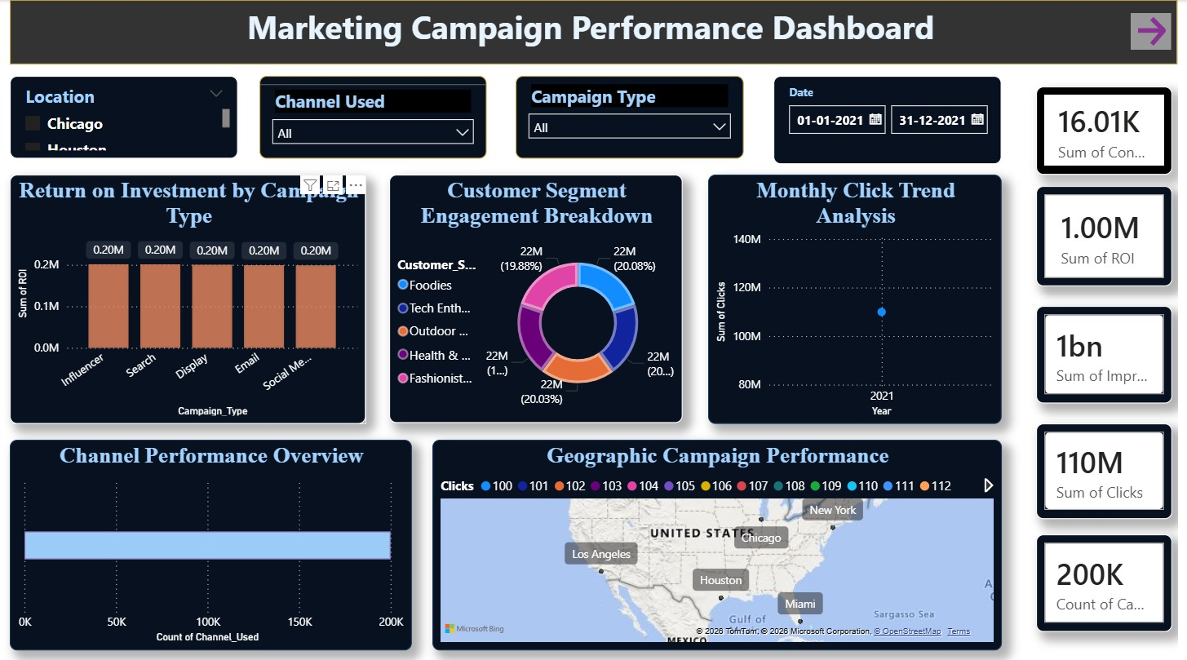

Appendix C abbreviation
• ROI – Return on Investment
• KPI – Key Performance Indicator
• BI – Business Intelligence
• DAX – Data Analysis Expressions
• CSV – Comma Separated Values
• UI – User Interface
• UX – User Experience
• ETL – Extract, Transform, Load
• API – Application Programming Interface

References
- Microsoft Power BI Official Documentation
- Microsoft Excel Documentation
- Research articles on Marketing Campaign Analysis and Data Visualization
- Online tutorials and learning resources related to Power BI and DAX
- Articles on Business Intelligence and Dashboard Design
These references were used to understand concepts and implement the project effectively.

